7.9: In Eq. (7.7), 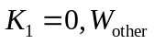 is given as 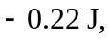 and taking 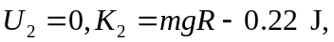 so
